

GUIDELINES FOR POSTER PRESENTATION:
Kindly adhere to the guidelines mentioned for the Poster Presentation
1. Format: The poster should be printed in hard copy only
2. Dimensions: The poster should be set in portrait orientation- 36” × 48” (36 inches in width and 48 inches in height).
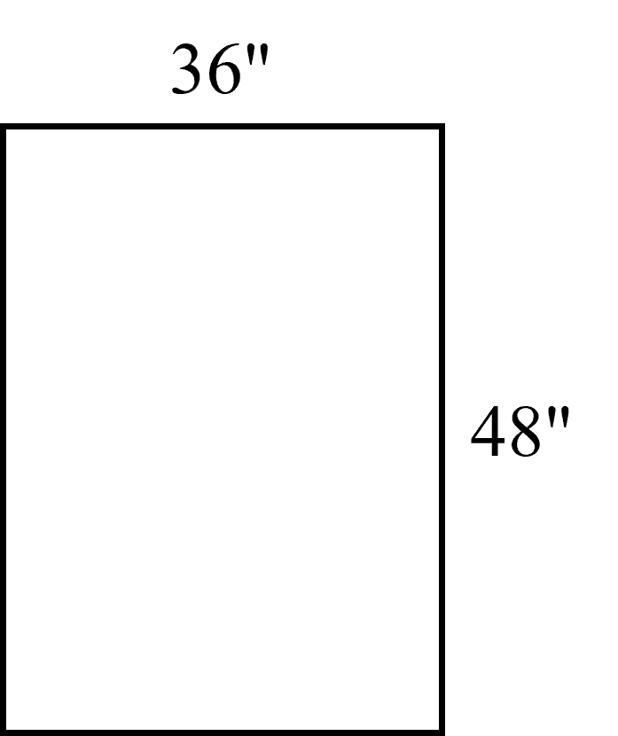

3. Top of the poster: Abstract ID should be mentioned in the top left corner. The names of all the authors and the affiliation of the presenting author should be mentioned at the top centre of the poster.
4. Subheadings: Background, Objectives, Methods, Results of Objectives completed until date, Conclusion, Keywords, References and Achievements
5. Bottom of the poster: Should contain the following: Presented at ICTBH 2026, Manipal Academy of Higher Education, Manipal.
6. Please use caution when choosing colours and pick backgrounds that contrast well with the font to make the content of the poster easy to read.
7. Kindly keep available details of your achievements in terms of publication, conference etc. during the presentation

