
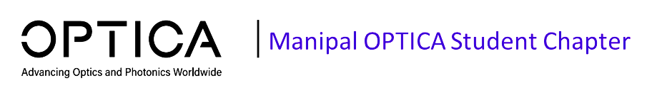
Preparing a Manuscript for Submission to an Optica Meeting or Conference [Title Should Be in Bold, 18-Point Type and Centered, Use Title Case]

Author name(s) [12-point type, centered, bolded, Presenter Name should be underlined]
Author affiliation and full address (9-point type, centered, italicized)
Corresponding author e-mail address: (9-point type, centered, italicized)

Abstract: Indent left and right margins 0.5 in. (1.27 cm), justify the paragraph (on both right and left), and use the same font as in the body of the paper. Your abstract should be an explicit summary of the paper that states the problem, the methods used, and the major results and conclusions. The abstract should be maximum 300 words. [12-point type, Times New Roman]

Keywords: Mention 5 keywords [12-point type, left-aligned, Times New Roman]

